Article

Q-SAR: Drone Swarm for Disaster Management

Ali Elmancy, Abdalla Ahmed, Assem Alnajjar, Khaled Soliman, Khaled Barakah, Omar Mousa, Abdullah Al Mawed, Moselm Al-Qawasmi, Yaman Kutmawi, Wadha Labda, Ahmed Abdou, Amr Mohamed.

|  |
| --- |
| **Citation:** To be added by editorial staff during production.  Academic Editor: Firstname Lastname  Received: date  Revised: date  Accepted: date  Published: date    **Copyright:** © 2024 by the authors. Submitted for possible open access publication under the terms and conditions of the Creative Commons Attribution (CC BY) license (https://creativecommons.org/licenses/by/4.0/). |

Qatar University, Doha, Qatar

**\*** Correspondence: e-mail@e-mail.com; Tel.: (optional; include country code; if there are multiple corresponding authors, add author initials)

**Abstract:** This study explores the implementation of unmanned aerial vehicles (UAVs) in enhancing search and rescue (SAR) operations following natural disasters. Recognizing the impediments of destruction and limited visibility, our project develops a drone swarm system equipped with advanced technological solutions to streamline SAR efforts. The system integrates wireless charging technologies to extend mission durations and employs radar sensors paired with machine learning techniques for precise detection of survivors. This approach achieves a high detection accuracy of 94.08% under various scenarios. Additionally, the drones are equipped with autonomous navigation capabilities, enabling them to independently traverse to targeted locations and return after mission completion. A robust backend system facilitates real-time monitoring and ground control, while a cutting-edge 5G communication framework supports seamless, high-speed data transmission across the drone swarm. These integrated technologies collectively enhance the speed, coverage, and efficiency of SAR operations, significantly improving emergency response effectiveness in disaster-stricken areas.

**Keywords:** UAV; Search and Rescue; Drone Swarm; Disaster Management; Autonomous Systems; Sensor Fusion; Machine Learning; 5G Communication, wireless power transfer (WPT); SS-topology.

1. Introduction

Unmanned Aerial Vehicles (UAVs), more commonly known as drones, have increasingly become integral to effective disaster management, particularly in enhancing the efficacy of search and rescue (SAR) operations post-natural disasters. Originally developed for military applications, UAVs have found extensive civilian uses due to their agility and capacity for carrying diverse payloads, which make them ideal for rapid situation assessments in disaster-stricken areas [1].

However, the operational deployment of UAVs is not without challenges. Ethical concerns, particularly regarding privacy and the potential for misuse, continue to spark debate. As drones become more embedded in civilian applications, addressing these concerns is pivotal to maintaining public trust and ensuring the broader acceptance of UAVs in humanitarian efforts [2].

Moreover, the integration of UAVs with emerging technologies such as 5G communications has opened new possibilities for drone swarms. This advancement allows for real-time data transmission over vast distances with minimal delay, enhancing coordination and efficiency across multiple drones during SAR missions. The ability to manage and monitor these drones through advanced web-based applications ensures that real-time updates are seamlessly integrated into disaster management efforts, providing crucial insights, and improving response times.

In parallel, computational advancements have propelled the development of more sophisticated drone-based detection systems. Algorithms such as those from the YOLO (You Only Look Once) series have been refined for drone use, enabling real-time, accurate object detection even in challenging environments. Each iteration, up to the latest YOLO models, has improved in handling the complexities of aerial image analysis, crucial for identifying survivors in disaster zones [3].

Significant advancements have been made in overcoming the limitations that once curtailed the broader application of drones in prolonged missions, specifically concerning energy efficiency. The adaptation of wireless power transfer (WPT) technology, mirroring innovations seen in sectors such as electric vehicles and healthcare, represents a critical evolution. These systems enable drones to recharge without direct contact, thus significantly extending their operational range and endurance in field conditions [4].

This research aims to holistically integrate these technological advancements into a unified drone swarm system designed for optimized SAR operations. By combining autonomous navigation, advanced machine learning for detecting humans under the rubble and object detection, and innovative power solutions, this project seeks to significantly enhance the operational capabilities of UAVs in disaster scenarios. The system’s design not only addresses the immediate needs of rapid and effective SAR operations but also underscores the potential of UAV technology to revolutionize disaster management and response strategies [5]. This comprehensive approach ensures that the project not only meets the current technological standards but sets a precedent for future innovations in UAV applications for disaster management. Top of Form

1.1 Literature Review

Search and rescue operations (SAR) are crucial to save lives and minimize losses in post-disaster scenarios. Therefore, different approaches have been investigated to optimize these operations as much as possible taking into consideration the challenges represented by the environment and the disaster. One of the solutions was the use of mobile robots due to their ability to maneuver and navigate in rough environments. Researchers in designed a semi-autonomous mobile robot that sends data to an operator through sensors. Another robot architecture suggested in introduces a robot that can be deployed in disaster locations and features Internet of Things (IoT) capabilities. In [8] the designed prototype robot is supposed to localize itself in unknown environments, find the victims, and get them to a safe location. Due to the destruction of buildings and obstacles that hinder rescue teams and might not be feasible for mobile robots to function, drones offer a proper solution to access these areas in minimum time because of their agility and flexible design that allows for a variety of functionalities to be added to the system [9][10][11].

Utilizing drones in managing disastrous events opens new horizons in disaster management by improving survivors' detection and counting as well as identification of injured people, especially those who are buried under rubble. The system developed in [12] uses a depth camera and lidar sensor to detect humans and map the surrounding unknown environment. The choice of lidar and depth infrared (IR) camera is due to their insensitivity to illumination and their good range since the experiments were conducted in a closed environment. The system is controlled by virtual reality (VR) equipment operated by the search and rescue team. The work proposed in [13] presents a customized drone built specifically for search and rescue operations (SAR) under 1000$, so it is less costly than what the market offers. The drone features a neural compute stick (NCS) to perform inference on the drone and limit the amount of data that has to be sent to the ground control station (GCS). The designed system was able to detect missing persons with high accuracy while being limited to the specified budget.

DronAID[14] provides an autonomous system that can detect people under the rubble regardless of the disaster. The system uses a passive infrared sensor (PIR) to detect IR radiation emitted by humans. The system offers streaming capability of camera feed to the server for further processing. The experiment conducted proved the system's functionality as it was able to detect humans under debris at an 8-meter distance. Another system is DRONA which is a drone that can be deployed in damaged locations [15]. The drone is equipped with a patient monitoring system to measure the vital signs of a lost human. In [16] researchers are using Wi-Vi sensor to detect people behind the walls. The paper shows that the technique is effective, however, it is still under development and not as common as other studied approaches. The work presented in [17] proposes a drone that can detect humans as well as being fully autonomous, which sets it apart from the previously discussed papers. For that purpose, the drone is making use of PIR sensors and ultrasonic sensors. If a human is detected, the coordinates of the GPS module will be used to determine its place.

In [18] researchers developed a drone that makes use of deep learning techniques especially convolutional neural networks (CNN), mainly YOLOv3. In the case of detection, the drone sends a notification packet to the ground station including different information like the number of detected humans as well as coordinates. Another developed drone in [19] used YOLOv5 for improved performance for human detection. The components used were mainly open-source and similar to what we are developing in this project. Another work that used YOLO was [20], where YOLOv4 was used along with a thermal camera to overcome weather constraints and night vision.

So far, most of the discussed literature focused on human detection with vision models, which implies that at least some body parts should be in the line of sight of the camera. However, in most cases, especially during earthquakes, too many people get trapped under rubble, so they become invisible to the drone, as a result, their rescue may be late until special teams arrive in the area. To tackle this problem, researchers in [21] proposed an acoustic sensor to detect humans under rubble through changes in chest motion caused by breathing. The frequency shift in the reflected signal indicates human presence. A different approach adopted in [22] utilizes microwaves for human detection using radar and the principles of Doppler’s effect. The system was tested against diverse types of barriers and produced acceptable accuracy at a limited distance. In [23] the system utilized a speaker that makes sounds for people trapped under rubble and detects them by capturing their reaction to the voice. To recognize human voice, a bandpass filter (BPF) was created to isolate the voice from the surrounding noise. A software tool is used to identify input words against words in a database, and if a victim is detected, record location information, time, and voice recognition results. Besides the later techniques, [24] discussed and assessed several methods but mostly focused on different radar technologies that could be used. A review of different radars was also conducted in [25] to determine the most effective approach when it comes to survivors buried under earthquake rubble. The work presented in [26] provides a design of a detection module that can detect humans through the wall using a microwave motion sensor. It builds on the same principle of Doppler’s effect. Although this solution was not designed for drones, it can be mounted on a drone due to its lightweight and minimal design.

Since affected areas are usually not small and might even include several neighborhoods, it can be difficult for a single drone to cover the whole perimeter, considering battery limits. Therefore, a swarm of drones represents a reasonable solution where drones coordinate communication among the fleet and cover the whole damaged area in a faster time which considerably facilitates the work for search and rescue teams. A suggested framework in [27] proposes a set of drones each does a specific task, like aerial photography, indoor navigation, and others which helps with different search and rescue tasks. Researchers in [28] presented an architecture in which a human operator controls the drones with a set of gestures and different commands. The architecture allows flexible levels of autonomy from completely autonomous to manually controlled by the operator. Another architecture designed in [29] where specialized drones, fixed wing, blimp, and rotary blades perform different tasks depending on their characteristics. The fleet divides the area into zones. If a drone has to leave its zone or sub-zones due to any reason like battery charging, then other drones should be informed to continue the mission.

Wireless power transfer (WPT) revolutionizes the traditional means of supplying electrical energy by eliminating the need for physical connectors and enabling the transmission of power over distances without the constraints of wires [30]. One of the prominent methodologies within WPT is inductive power transfer (IPT), which operates based on the principle of mutual inductance between two coils, where alternating current in one coil induces a current in the other [31,32]. Conversely, capacitive power transfer (CPT) relies on the principle of electric field coupling between two electrodes separated by a dielectric material, offering an alternative approach particularly suited for applications demanding higher efficiency over longer distances [33]. Compensating circuits play a crucial role in enhancing the efficiency and reliability of power transmission systems. Two notable compensating circuit topologies are SS (Series-Series) and SP (Series-Parallel). The SS compensating circuit topology is characterized by a series connection of the transmitter and receiver coils, enhancing the coupling coefficient between the coils and consequently improving power transfer efficiency. By aligning the resonant frequencies of both coils and mitigating impedance mismatches, SS compensation minimizes power losses and maximizes power transfer efficiency, making it well-suited for short-range WPT systems such as wireless charging pads [34,35]. On the other hand, the SP compensating circuit topology combines series and parallel connections of the transmitter and receiver coils, offering greater flexibility in adjusting resonance frequencies and impedance matching to optimize power transfer across varying distances and load conditions [34].

1. Materials and Methods

The proposed system architecture depicted in Figure 1 consists of three main components: a drone swarm, a Command-and-Control Center (CCC), and wireless charging stations, all operating in seamless coordination. The drone swarm employs a two-tier architecture featuring high-altitude drones (HADs) and low-altitude drones (LADs). HADs are tasked with conducting initial scans of the affected area and transmitting live video feeds to the CCC. Leveraging object detection models, the CCC processes these feeds to identify potential locations of rubble where someone might be trapped in addition to detecting visible humans and those who need help. The GPS coordinates of these locations are then relayed to the LADs. LADs, equipped with advanced sensors and radars, are dispatched to the identified coordinates for focused scanning and survivor detection. Their optimal flight paths are computed by the CCC, treating the problem as a traveling salesman optimization, ensuring efficient coverage without redundancy. At the core of each drone is a companion computer, functioning as the processing unit. It interfaces with the drone's autopilot, collects data from onboard sensors, and handles communication with the CCC. Visible survivor detection is accomplished through camera feeds transmitted to the CCC, while non-visible targets are identified by the LADs' radar systems, with relevant data forwarded to the CCC. Communication between the drones and the CCC is facilitated through two dedicated channels: one for telemetry data, ensuring real-time monitoring of each drone's status, and another for transmitting high-resolution imagery upon event detection, such as survivor sightings or structural damage. This dual-channel approach ensures smooth data transfer and efficient management on the server side, leveraging high-speed 5G networks and reliable protocols. The CCC serves as the mission control hub, responsible for initializing the drones, assigning GPS coordinates, and transmitting high-level control commands from human operators when necessary. It also provides a centralized dashboard for mission monitoring and maintains a database for storing and analyzing mission data. To support extended operations, wireless charging stations are strategically placed at the periphery of the affected area. These stations communicate their availability status with the CCC, enabling centralized management of drone charging and preventing simultaneous charging at the same station.

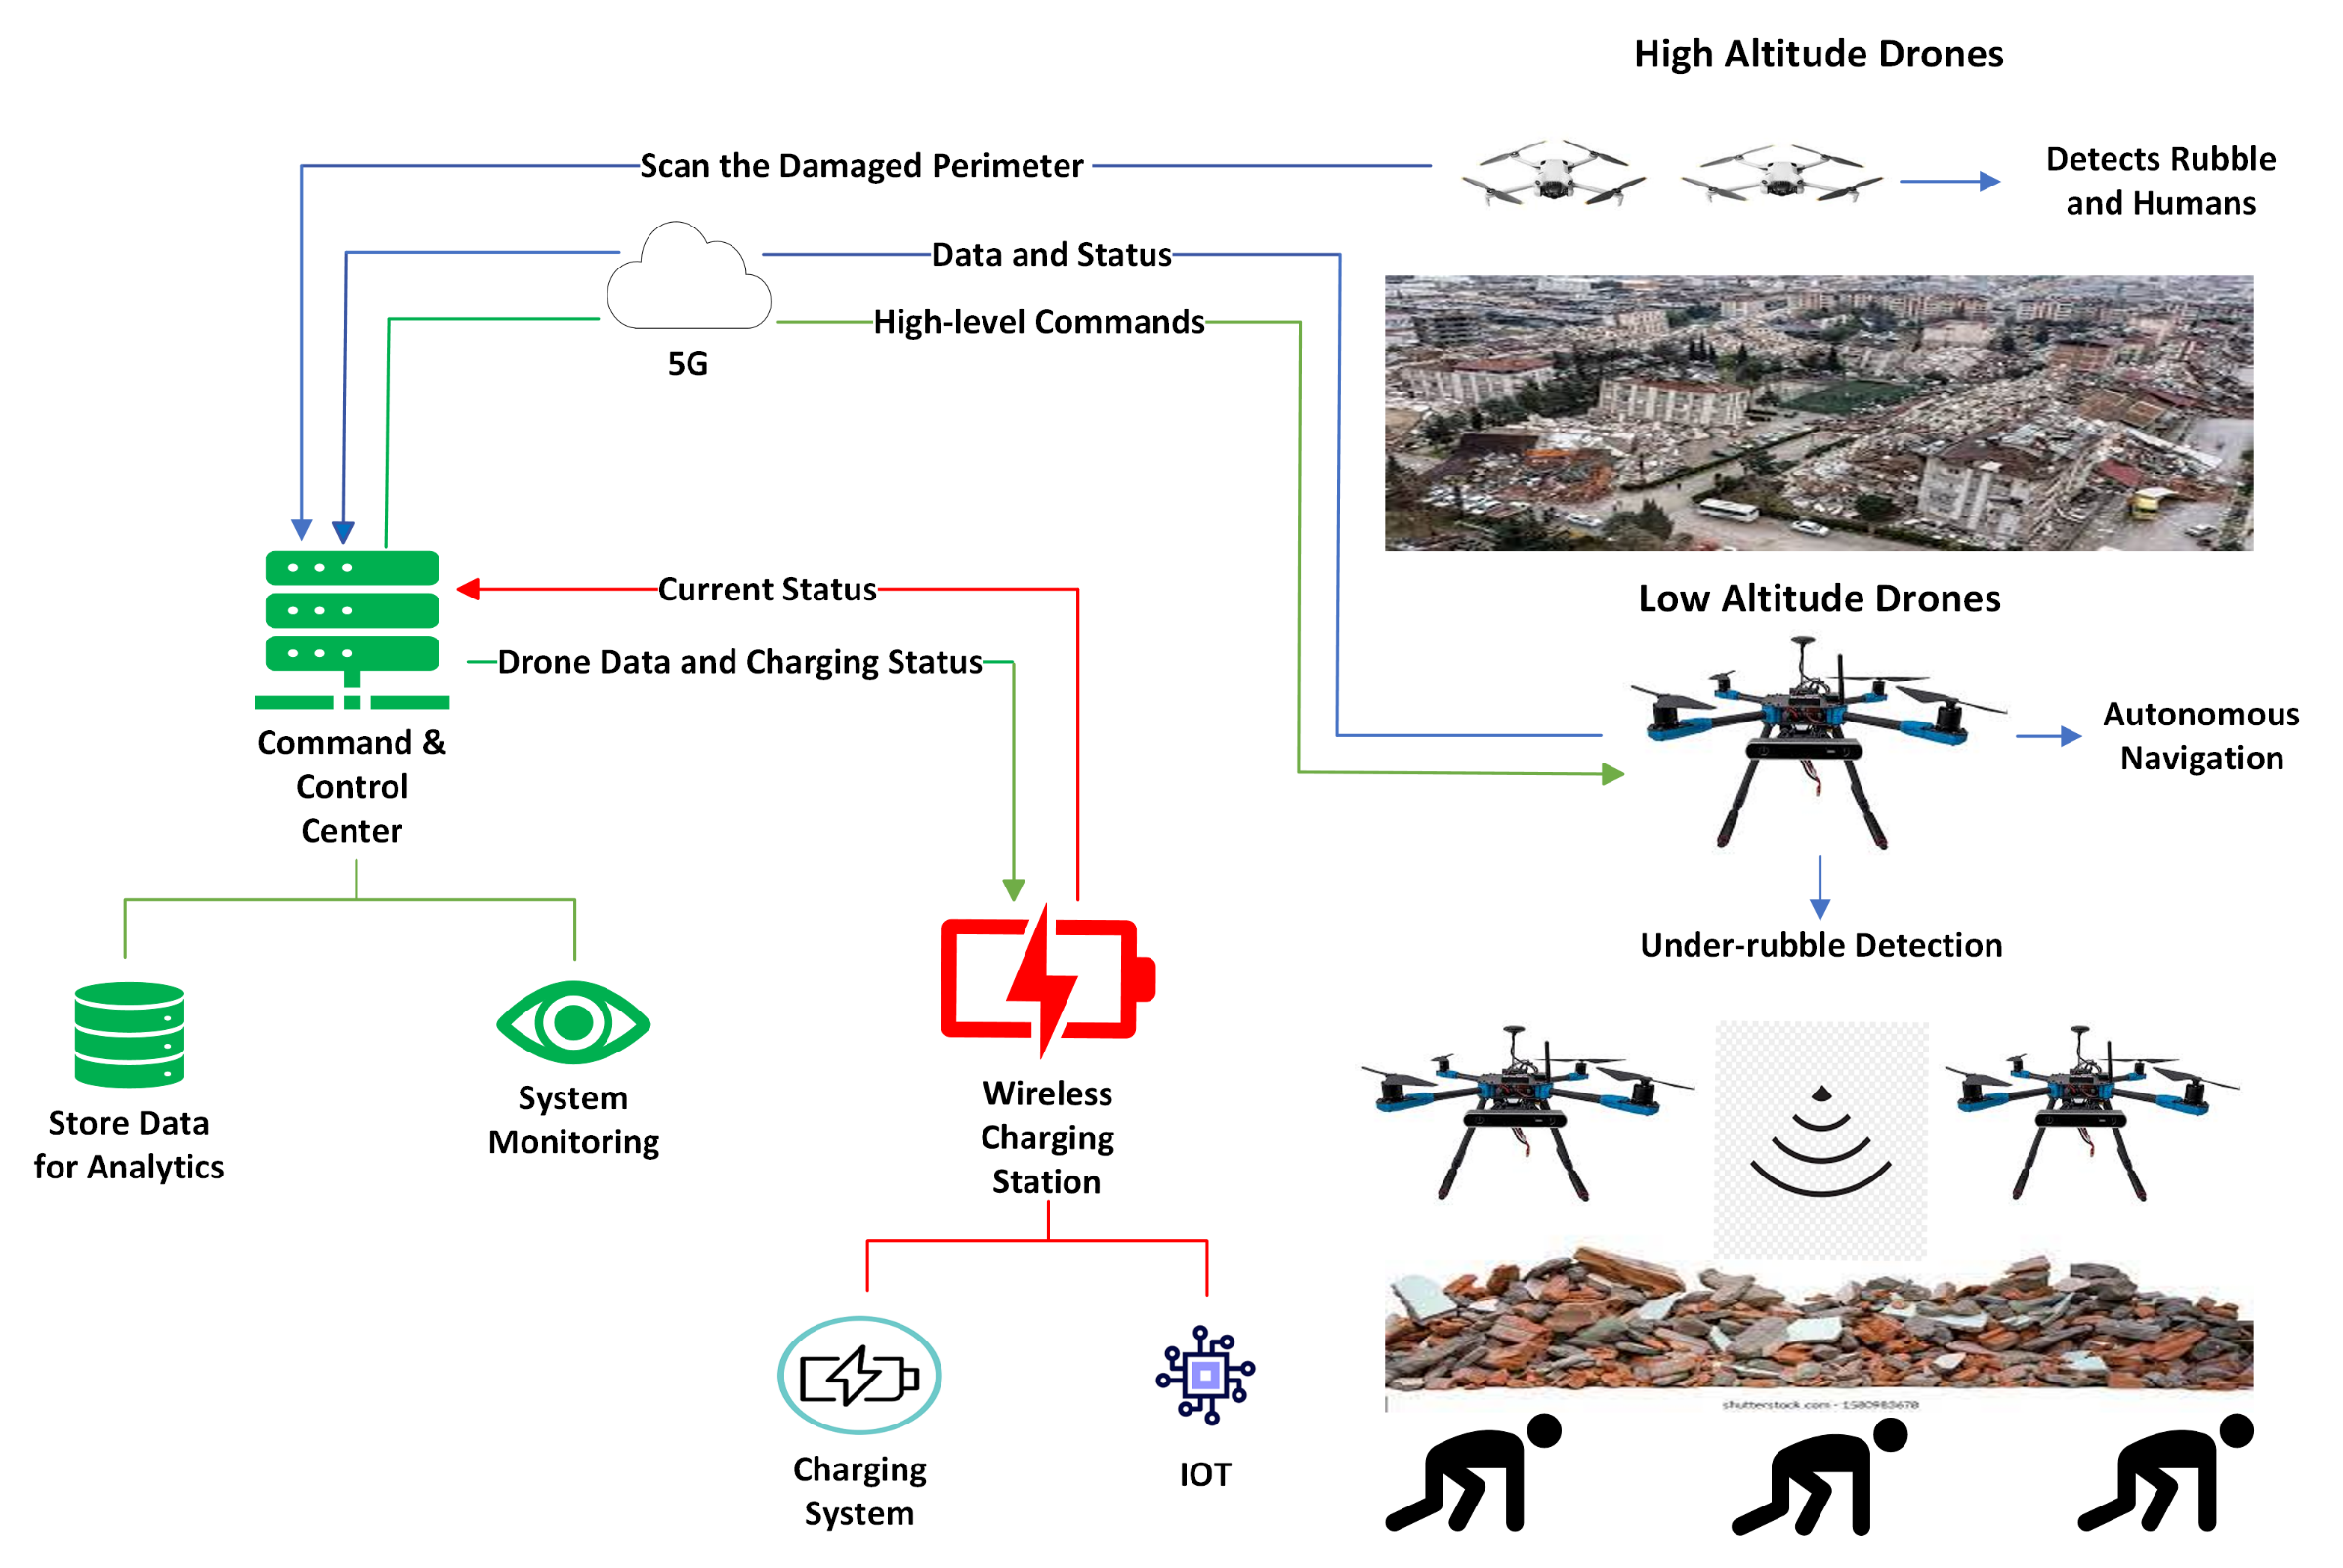

**Figure 1.** System Architecture

2.1 Drone Design

Since the HAD could be a commercial drone and its functionality is limited, the following discussion focuses on the LAD and the systems that will be integrated with it. The chosen drone kit is the Holybro PX4 Development Kit – X500 v2, plus a 6500 mAh LiPo battery. This kit includes a quadcopter frame with motors, propellers, ESCs, a power distribution board, autopilot, and a GPS module. **Table 1** shows the details of the drone and its hardware components.

**Table 1.** Drone Specifications

|  |  |  |
| --- | --- | --- |
| Component | Specifications | |
| General specifications | Drone Type | Quadcopter |
| Make and Model | Holybro PX4 Development Kit – X500 v2. |
| Wheelbase Dimensions (mm) | 500 mm |
| Frame Body Dimensions (L*W) (mm) | 144 mm*144 mm |
| Dimensions with propellers (mm) | 630 mm * 630 mm * 247 mm |
| Weight (g) | 610 g |
| Materials Used | Carbon fiber, plastic, and fiber reinforced nylon. |
| GPS | M10 GPS module |
| Telemetry Radio | SiK Telemetry Radio V3 |
| Motors | Model | AIR2216II |
| RPM when supplied with 1 Volt (KV) | 920 KV |
| ESCs | Model | BLHeli S 20A |
| Constant Current (A) | 20 A |
| Peak Current (A) | 30 A |
| Throttle Signal Frequency (Hz) | 50 Hz – 600 Hz |
| Power Connector | XT30 |
| Propellers | Model | T1045II (two blades) |
| Size (in) | 10” |
| Pitch (in) | 4.5” |
| Thrust Limitation (Kg) | 1.2 Kg |
| PDB | Make | Holybro |
| Power Connectors | XT60 for battery, XT30 for other peripherals like ESC. |
| Autopilot | Model | Pixhawk 6C |
| Power Module | PM02 V3 |
| Battery | Model | The hobby land 14.8V 6500 mAh 75C 4S LiPo Battery |
| Weight (g) | 480 g |
| Maximum voltage (V) | 14.8 V |
| Electrical Charge (mAh) | 6500 mAh |

2.2 Under-rubble Detection

Detecting humans beneath is a challenging task as the sensor to be used has to be able to penetrate materials yet provide high accuracy. Therefore, multiple options were investigated according to the performed research and based on what has been used in previous literature. Due to the importance of accurate detection, multiple sensors were employed for this task and sensor fusion with machine learning was utilized to improve the detection process. A wide range of sensors were investigated, such as thermal cameras, radar sensors, PIR, and voice sensors. Thermal cameras were proven to be effective if part of the trapped human is visible; however, it cannot penetrate any material. Voice recognition sensors were also considered, but they require intensive signal processing and may not function properly if the survivor is not able to scream or other sounds from the environment are being falsely detected. Therefore, these two options were ignored, and we have chosen to explore two radar techniques [36] and PIR sensors because they can be seamlessly integrated into our system.

Radar technology offers distinctive advantages as it can penetrate various materials; however, the extent of penetration depends on material properties and signal characteristics. Previous studies have demonstrated that radars can capture vital signals of humans through walls [25]. The chosen radar sensors are compact and lightweight, meeting the limitations of the drone payload capacity. As detailed in [24], Frequency-Modulated Continuous Wave (FMCW) radars were identified as a potential solution to detect buried survivors. Moreover, the ultra-wideband technique (UWB) was used in [26] and showed that it can detect human presence through the wall. Therefore, two sensors were used for testing: the Parallx X-Band Motion Detector, leveraging UWB technology, and the DfRobot mmwave - 24GHz Microwave Radar Distance Sensor, which utilizes the FMCW principle. The third sensor is the PIR sensor. It has been used in previous research and provided some distinctive results [14]. PIR sensor is easy to work with and does not require extensive processing due to its passive nature but it was proven to be unusable in our case.

Frequency-Modulated Continuous Wave (FMCW) Radar: The FMCW radar operates by continuously emitting a chirp signal and monitoring changes in the phase and frequency of the reflected signal. This technology requires stable mounting due to its sensitivity to even slight movements. The sensor under evaluation transmits signals around 24 GHz, which is relatively high compared to Ultra-Wideband (UWB) radar. Higher frequencies may result in limitations in signal penetration through obstacles and more rapid power dissipation, posing challenges in accurately capturing vital signals. The UWB radar emits a short-duration impulse signal, spanning a broad frequency spectrum. It subsequently awaits the return of the signal reflected from the target object. The received signal contains information about the object’s movement. A series of signal processing algorithms is then applied to this signal, enabling the extraction of vital signs and the detection of human presence. A distinctive merit of the UWB radar is its operation around 10 GHz frequency, which provides supposedly good penetration capability with less power loss during signal transmission. A thorough discussion of the two techniques is presented in [37].

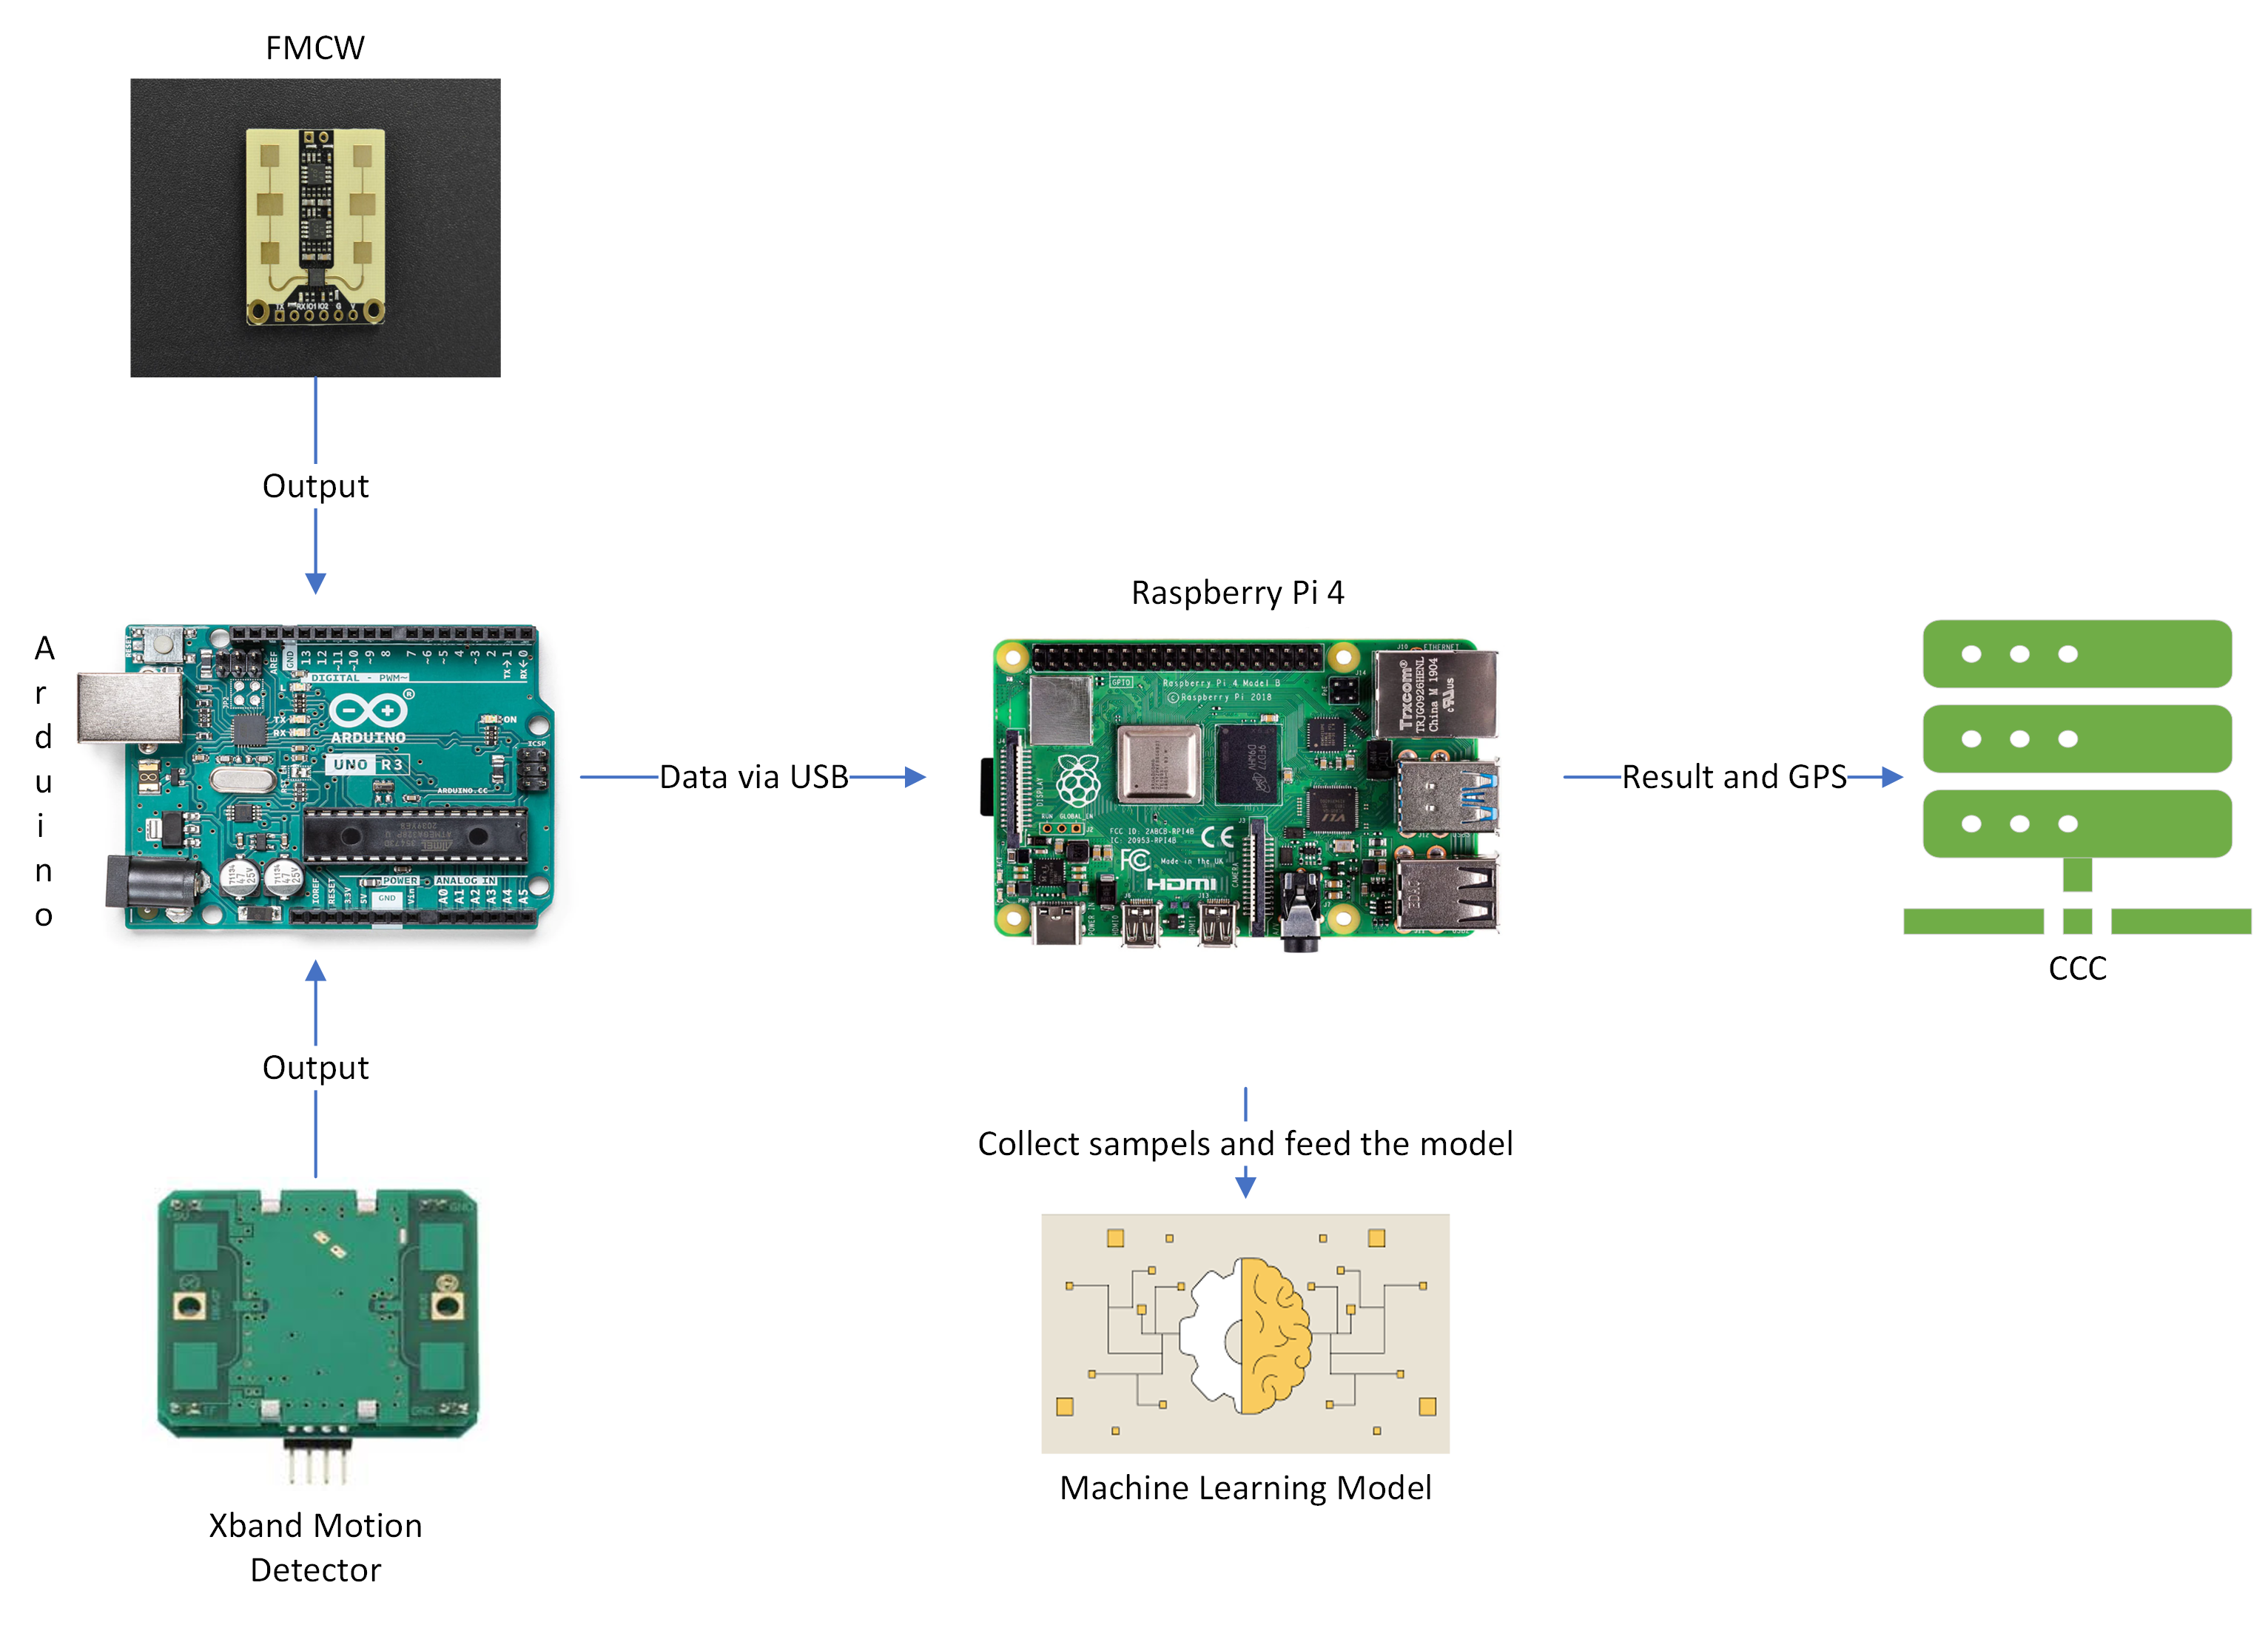

**Figure 2.** Under-rubble Detection System

As shown in **Figure 2** using the output of these sensors is essential for having accurate detection results. For this purpose, a machine learning model will be used to obtain the result given a set of sensors’ readings over 10 samples. To construct the machine learning model, a dataset was collected at three phases using radar sensors since the PIR has proven to be insufficient for penetrating materials like wood. In the first stage, an experiment was conducted at three different levels of altitude: 2m, 175m, and 1.5m. Around 12000 samples were collected, evenly split between scenarios of detection and no detection, with 2000 samples collected at each altitude. The features taken into consideration were the Doppler frequency, UWB detection result, FMCW detection result, and altitude. During this stage, we assumed perfect drone stability and that the sensors were not affected by the throttle or drone vibrations, so the sensors’ readings were taken while they were hung stably. In the second stage, stability was still assumed but we added bricks as rubble and collected the data to see how the model performs with different materials. In the final stage, we collected the data while the drone was hovering to see how the accuracy degrades when the sensors are not stable and produced the final dataset which is a combination of the stable and hovering data. **Table 2** provides a summary of all the data collected across all phases. It is worth mentioning that we added the hovering feature when combining the stable and hovering datasets so that the model can distinguish between the state at which the data point was collected. In addition, to balance the datasets, we randomly sampled 482 of each label from the stable wood dataset to be added to the stable bricks forming the stable dataset.

**Table 2.** Datasets Summary

|  |  |  |
| --- | --- | --- |
| Dataset | Number of samples (No detection) | Number of samples (human detected) |
| Stable Wood | 6000 | 6000 |
| Stable Bricks | 500 | 500 |
| Stable Bricks + Wood | 982 | 982 |
| Hovering | 482 | 482 |
| Consolidated dataset 1 (with hovering feature) | 1464 | 1464 |
| Consolidated dataset 2 (with no hovering feature) | 1464 | 1464 |

Three machine learning classification models: logistic regression, random forest, and decision tree were trained on the datasets. These models are known for being used in classification problems providing a good performance to our problem and could be hosted on edge without stressing the processing capacity of the hosting computer.

For model inference, 10 data points are read from the Arduino. Each one is passed to the model to get the probability of detection. If it passes a threshold of 30% it will be considered positive to increase the model recall. After that, the mean of the predictions list is calculated to provide a probabilistic result over all predictions which will be shared with the CCC.

2.3 Autonomous Navigation

Using the Dronekit library, the companion computer can perform autonomous missions by sending commands to the drone controller, and the drone will fly autonomously to a defined set of GPS coordinates. Therefore, the navigation program starts by receiving these points and planning the mission. While the drone is heading to its designated locations it will be consistently checking for obstacles to avoid so that it reaches its destination safely, performs the required action, and then comes back to the launch point or goes for charging if needed. **Figure 3** explains the navigation process.

**Figure 3.** Autonomous Navigation Flowchart

2.4 Communication

In this framework, CCC is hosted on Google Cloud Services. The flight controller, specifically the Pixhawk6c, manages crucial data such as GPS and compass information, battery percentage, and voltage, and oversees the drone's movement, base location, and mission coordinates. The companion computer plays a crucial role in connecting various drone subsystems, including the camera, sensors, and flight controller. It collects status data and facilitates communication with CCC. Its duties involve sending mission data, receiving high-level commands, and initiating the mission. **Figure 4** shows the communication process and the data being transmitted through the system.

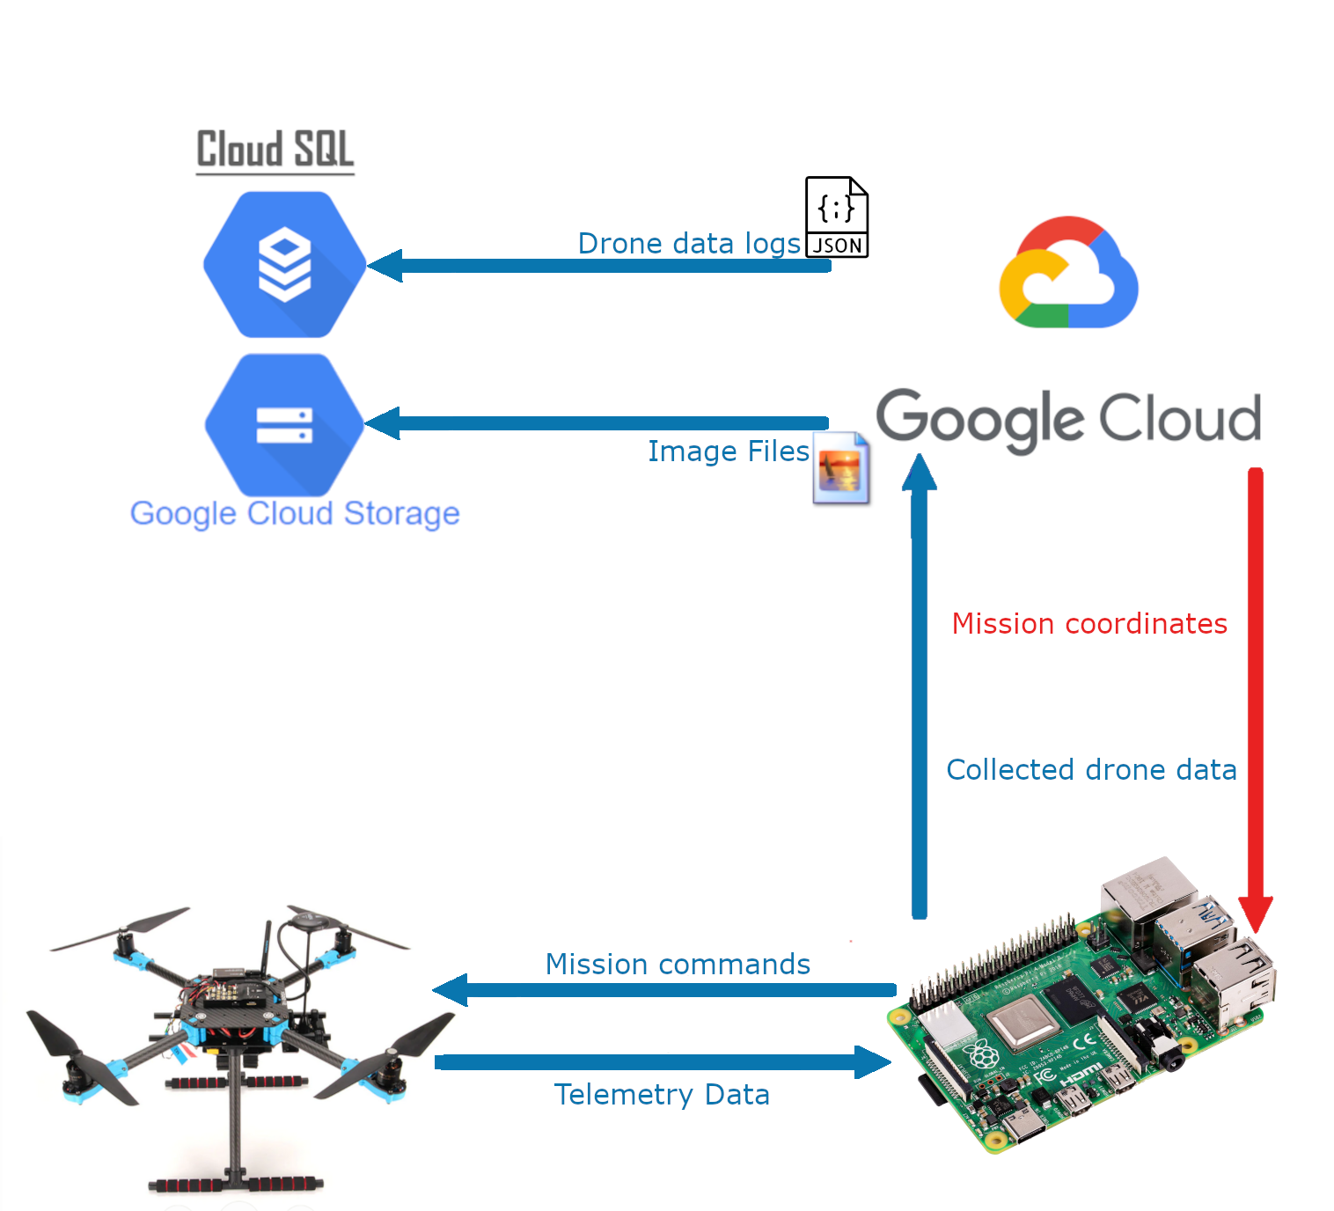

**Figure 4.** Communications Scheme

Mavlink is the protocol that enables communication between the flight controller and the companion computer. Following a modern hybrid publish point-to-point design, Mavlink sends data streams as topics, sharing them with all nodes in the network. Meanwhile, configuration sub-protocols are sent from point to point with retransmission. It transmits data in packets that vary in size between 8 bytes to 163 depending on the payload size, it is highly dependable as Mavlink has been utilized since 2009 for communication among various vehicles, ground stations, and other nodes across diverse and demanding communication channels, even those with high latency or noise. It offers mechanisms to identify packet drops and corruption and enables packet authentication. Mavlink Packets are formatted into serialized multi-byte fielded structure, the wire format for Mavlink v1 packets is depicted in **Figure 5**.

**Figure 5.** Mavlink v1 Frame.

To access the telemetry data stream from the flight controller, Dronekit library used to communicate over Mavlink. Telemetry data is received by the companion computer through the USB port from the flight controller. A Python script, using Dronekit establishes a connection with the Mavlink data stream on a serial channel. Subsequently, drone status data is collected with the sensor readings in the case of the LAD and sent to CCC's database via Google's Pub/Sub service, enclosed in a JSON file following a predefined schema. Simultaneously, a separate stream sends selected camera frames in the case of the HAD to CCC's image storage.

2.5 Command and Control Center

In the development of a comprehensive drone system for search and rescue operations, the Command and Control Center (CCC) serves as the critical nexus for operational management and strategic oversight. The CCC integrates a refined version of the YOLOv8x model, specifically adapted to enhance the detection capabilities of UAVs in varied disaster environments. This advanced detection algorithm allows for the precise identification of survivors from aerial images, achieving high accuracy crucial for timely and effective rescue missions.

Central to the CCC's functionality is a robust web application, engineered to provide an intuitive user interface for SAR operation coordinators. This interface facilitates the real-time monitoring and control of drone swarms, offering features such as live mapping of drones' positions, trajectory visualization, and direct manipulation of mission parameters. This setup not only enhances situational awareness but also enables decisive action during critical phases of SAR operations. More about the architecture of the subsystem is explored in **Figure 6**.

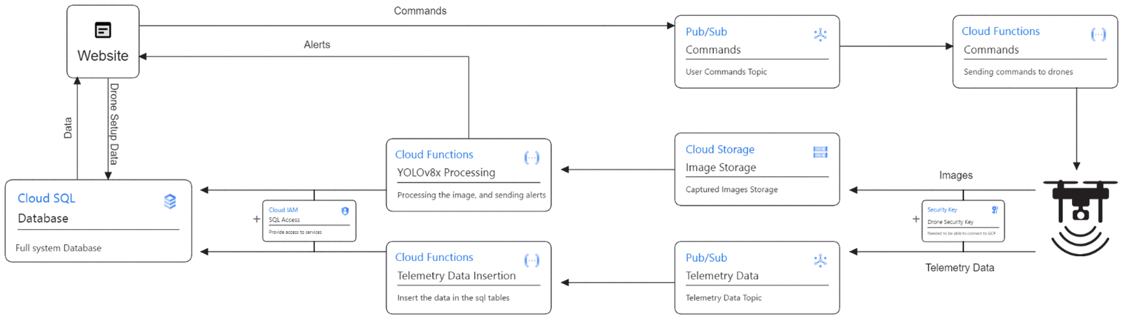

**Figure 6.** CCC System Architecture

The architecture of the CCC ensures seamless data flow and system interaction. Images captured by drones are promptly uploaded to a secure cloud storage, where they are processed using the customized YOLOv8x algorithm. The processed data, along with continuous telemetry feeds, are streamed back to the web application, allowing for dynamic mission management. The system supports secure and efficient data transmission protocols, ensuring that all communications between the drones and the CCC are encrypted and reliable.

Additionally, the CCC's design includes mechanisms for manual override, granting operators the ability to intervene and alter drone operations in response to evolving on-ground conditions. This feature is vital for addressing unexpected challenges and optimizing the deployment of resources during live missions.

By consolidating advanced detection algorithms, secure data handling, and interactive mission control into one platform, the CCC significantly amplifies the effectiveness of UAVs in disaster scenarios. This integration not only streamlines operations but also underscores the potential of sophisticated UAV technology in revolutionizing search and rescue efforts under challenging conditions.

2.6 Wireless Charging

The wireless charging block diagram shown in **Figure 7** contains the main design blocks of the system, including a sending-end component, transmitting and receiving coils, and a receiving-end component.

**Figure 7.** Wireless Charging System Block Diagram

The sending end components is responsible for converting the DC supply voltage to AC voltage utilizing Silicon carbide Mosfets in addition to a gate driver to drive the inverter, and a microcontroller (f2800157 C2000) to generate the gate signal controlling the Mosfets at the specified frequency of 100kHz which been chosen to prevent any interaction with the different components while having minimal switching losses.

The optimal WPT is achieved through implementing the SS topology due to its high efficiency and misalignment tolerance. The SS topology compensating circuit contains a capacitor in series with an inductor (coil) on both the primary and secondary sides; it is the core of wireless charging, where power is transferred through the magnetic field generated between the two coils. The primary and secondary coils are designed in a circular pad structure due to the highest efficiency achieved in power transfer as stated in [34,35].

The receiving-end component acts as a rectification stage responsible for con-verting the AC output voltage from the compensating circuit into DC voltage using the KBPC- 3510 full wave bridge rectifier due to its high specifications that meet the design requirements. The rectifier produces a DC voltage ripple, however, charging the drones’ battery requires a constant DC voltage. Obtaining the suitable constant DC voltage is achieved through a filtering stage using a capacitor in parallel to the rectifier.

The control system is designed to have a closed loop controlled system which gives the ability to control the input voltage depending on current/ voltage reading from the secondary side, the system uses the Texas Instruments C2000 DSP (F2800157) connected to the USM-3IV voltage and current sensor to read the voltage and modify the inverter gate signal accordingly, the system uses a PID controller to get the fastest response with minimal steady-state error.

**Figure 8.** Closed Loop Block Diagram

3. Results

3.1. Sensor Testing

Three sensors were evaluated: the UWB radar, the FMCW radar, and the PIR sensor. The PIR sensor has a maximum detection range of 7 meters, as per its datasheet specifications. However, it is important to note that the PIR sensor operates by detecting a difference in infrared (IR) readings between its two probes, which occurs when an object moves across its field of view. Consequently, the PIR sensor is incapable of detecting micro-motions such as heartbeats and breathing. Furthermore, the PIR sensor has an inherent limitation: if an object is initially detected in motion but subsequently becomes stationary, the sensor will no longer be able to detect its presence. This is due to the absence of any change in IR readings once the object stops moving. In other words, for the PIR sensor to continuously detect an object, the object must be in constant motion. **Table 3** shows the testing results of the PIR sensor. Because of its inconsistent performance, it was not included in the machine learning training since it is accurate only when the target is in line of sight, which is not our scope.

**Table 3.** PIR Testing Results

|  |  |  |  |  |
| --- | --- | --- | --- | --- |
| Test Scenario | Range from Sensor (m) | Detecting Small Moves | Detecting Big Moves | Detection Accuracy (out of 5) |
| Test 1: Detection performance without obstacles with dome | 0 to 4 | Yes | Yes | 5 |
| 5 | Yes | Yes | 4 |
| 6 | No | Yes | 2 |
| 7 | Yes | No | 1 |
| Test 2: Detection performance with wood obstacle without dome | 0 to 1.5 | No | No | 1 |

FMCW Radar:

* According to the datasheet, the FMCW radar has a detection range of up to 9 meters.
* It has the advantage of being able to detect micro-motions, such as human vital signals, using the Doppler effect, which sets it apart from the PIR sensor.
* To avoid false readings due to high reflectivity from metallic materials, the tests were conducted in an environment with minimal metal objects.
* In tests without obstacles, the FMCW radar successfully detected human presence, both stationary by detecting micro-motion and moving, within its specified range of 0 to 9 meters.
* When testing its penetration ability, the FMCW radar could detect humans (moving and stationary) through wood within a range of 3 meters from the sensor.

UWB Radar:

* The UWB radar underwent similar tests as the FMCW radar.
* It demonstrated better resilience to vibrations compared to the FMCW radar.
* However, the UWB radar required more apparent movements to detect motion or presence reliably.
* Both the FMCW and UWB radars could penetrate wooden materials without significant performance degradation.
* However, they struggled to penetrate concrete and brick walls with a thickness of 15 cm or more.

3.2. Model Selection and Evaluation

The models chosen for classification were logistic regression, random forest, and decision tree. The datasets were split into training and testing sets which are 70% and 30% of the data respectively. In the first stage of dataset collection, we trained initial models in order to choose the most appropriate model. As can be shown in **Table 4**, the random forest classifier was the most accurate. Not only that but it also has the highest recall which is an essential metric for the model since we would like the model to be more sensitive to positive cases even if it means more false positives. Based on the results from the table, the random forest model will be used for detection.

**Table 4.** Models Metrics on Stable Wood Dataset

|  |  |  |  |  |
| --- | --- | --- | --- | --- |
| **Model/Metrics** | **Accuracy** | **Precision** | **Recall** | **F1 Score** |
| Logistic Regression | 97.07% | 97.73% | 98.22% | 98.70% |
| Random Forest | 98.75% | 98.40% | 99.11% | 98.70% |
| Decision Tree | 98.69% | 98.50% | 98.89% | 98.70% |

To understand which features are most important to the model, the bar chart in **Figure 9** shows that in the case of perfect stability, FMCW was the most influential feature while the altitude had minimal impact.

**Figure 9.** Feature Importances for Random Forest Classifier on Stable Wood Dataset

To further support this result, the dataset was split based on the values of the altitude feature, 1.5m, 1.75m, and 2m, and the model was trained on each of them. As shown in **Figure 10**, the accuracy is almost stable meaning that altitude does not result in accuracy degradation. Therefore, it has been removed from the following experiments since the drone is going to perform detection hovering at 3m. It is worth noting that altitude is not consistent due to the wind effect which changes the drone’s position, so the drone tries to maintain an altitude between 2m and 3m. In addition, when the drone is hovering, the altitude value fluctuates randomly without a meaningful correlation with the detection result, so it is less likely to affect the outcome.

**Figure 10.** Random Forest Classifier Accuracy vs Altitude

**Table 5** summarizes the performance of the model trained on the gathered datasets during different phases of testing. We can see that as the altitude feature was removed the accuracy dropped slightly; however, this scenario assumes perfect stability which is not the case when the drone is hovering. In addition, the model showed great performance with different materials like bricks. Moreover, the accuracy drops when the drone is hovering which is expected due to the false positive readings by the sensors as they are affected by motion. However, the trained model on the second consolidated dataset consisting of both stable and hovering datasets combined is still performing relatively well with an accuracy of 94.08%. Furthermore, it can be noticed that the recall dropped significantly as drone motion came into play; however, this issue can be addressed by lowering the confidence threshold of the model predictions.

**Table 5.** Model Accuracy and Recall Summary

|  |  |  |
| --- | --- | --- |
| **Dataset** | **Accuracy** | **Recall** |
| Stable Wood (with altitude) | 98.75% | 99.11% |
| Stable Wood (with no altitude) | 97.93% | 97.93% |
| Stable Bricks | 100.00% | 100.00% |
| Stable Bricks + Wood | 98.64% | 99.66% |
| Hovering | 93.79% | 91.72% |
| Consolidated 1 (with hovering feature) | 95.68% | 95.67% |
| Consolidated 2 (with no hovering feature) | 94.08% | 92.03% |

Looking more into the final model, **Figure 11** shows that Doppler is the most important feature contributing the most to the classification outcome. In addition, since the dataset is a combination of hovering and stable conditions, we can see that the FMCW is still important to the model especially when stable.

**Figure 11.** Feature Importance on Consolidated Dataset 2

To determine the optimal prediction probability threshold to set the model output to 1, an analysis was conducted to observe how recall and precision vary across different thresholds. As depicted in **Figure 12**, it can be observed that recall reaches its peak, 95.67%, at lower probability thresholds, although this adversely impacts model accuracy. Notably, at a threshold of 0.4, there's a notable shift in the curves, with precision showing a steady increase while recall declines. Consequently, setting the threshold to 0.3 emerged as a viable option, yielding a substantial increase in recall to 94.99%, compared to the default threshold of 0.5, where recall stood at 92.03%, and to the maximum value, it can be seen that it decreased slightly. Moreover, **Figure 13** supports these findings, demonstrating a consistent decrease in accuracy as recall increases. To achieve a balance between recall and accuracy, we plotted the average of both metrics, revealing a peak at a threshold of 0.3. While this adjustment resulted in a decrease in accuracy to 92.38%, it reflects a necessary trade-off to enhance the model's sensitivity to positive cases.

**Figure 12.** Recall and Precision vs Prediction Probability Threshold

**Figure 13.** Recall and Accuracy vs Prediction Probability Threshold

3.3. wireless power transfer

Practically implementing the methods stated in section 2.6, results in the overall WPT system shown in **Figure 14**.

**Figure 14.** Practical System Connections

After several tests on the WPT system, the maximum power transfer achieved for compensating circuit before the rectifier is 100 W, however, the output power after the rectifier was 75.6 W (charging power). These results were obtained by supplying the system with 70 V DC input voltage with an input current of 1.6 A, the inverter converts this voltage into an AC form required by the circular coils, the coils are separated by an air gap of 4.5 cm, the AC output voltage is then rectified and filtered by the rectifier and capacitors of the receiving-end component achieving the receiving-end voltage and current as 72 V and 1.05 A, respectively. The results finally obtained are using a resistive load with R matching of 50 Ω. **Figure 15** below shows the input supply and the output power results, in addition, **Figure 16** illustrates a graph that shows the Output power versus efficiency and input voltage

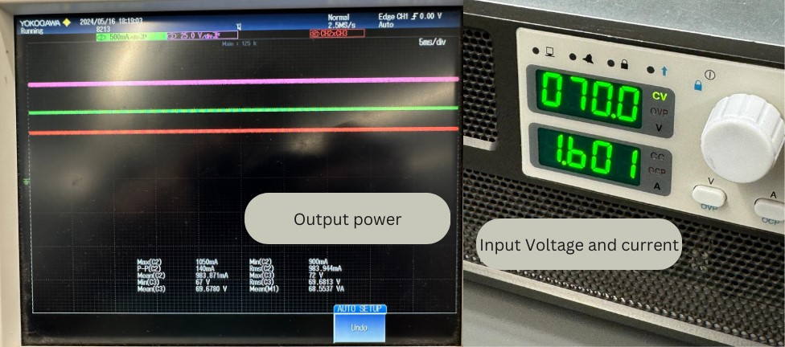

**Figure 15.** Output Power and Input Power

**Figure 16.** Output Power vs Input Voltage and Efficiency

The addition of the controller is essential in achieving these outcomes after the addition of the battery since the voltage and current can be maintained constant with the variation of the resistance of the battery during the charging status, the used voltage sensor is limited to dividing the voltage reading by 10 or 100, meaning if the supply voltage is 30V with the 10x mode, the ADC will read 3 V, making it the maximum reading the 12-bit ADC can handle, while with the 100x mode 30 V reading with correspond to 250 mV making the values reading very small which will affect the controller response and increase the error. To solve this problem, a simple voltage divider circuit was added to increase the range of the 10x mode of the inverter, making the maximum voltage reading 200 V corresponding to 3 V having R1=6.8kΩ and R2=100Ω, the control system is shown in **Figure 15**.

**Figure 17.** Control System Connections

4. Discussion

This study has explored various aspects of sensor integration, model selection, and operational factors influencing a drone-based detection system. Our findings provide important insights into sensor performance, machine learning model efficacy, and the dynamic interplay of environmental factors with technology. Here, we discuss the implications of these results and propose directions for future research.

The inherent limitations of the PIR sensor, notably its inability to detect micro-motions and its dependence on continuous motion and the object being in the line of sight, have led to its exclusion from the machine learning training phase. In contrast, the FMCW and UWB radars demonstrated notable strengths in micro-motion detection and resistance to vibrations, respectively. However, their penetration capabilities varied significantly with the thickness of the material, especially with bricks, showing good results when it is within 10 cm. These observations are crucial for refining sensor selection and deployment strategies in real-world scenarios.

The choice of the random forest model was justified based on its robust accuracy and recall, outperforming other considered models such as logistic regression and decision trees. Feature importance analysis revealed that FMCW radar was pivotal under stable conditions, while Doppler effects gained prominence in scenarios involving both stability and drone motion. This finding is interesting because although the threshold for the UWB sensor to detect motion is the Doppler to be over 5, the model learned that with different materials there could be motion detected even with the Doppler value being less than the threshold.

Our results indicate that model performance was consistent across various altitudes, leading to the decision to omit altitude as a feature in further tests. This suggests that the model's effectiveness is maintained regardless of minor variations in drone elevation.

To increase the model’s recall, the prediction threshold was adjusted so that the model is more sensitive to positive instances in order to make sure that it does not miss on any survivor.

When optimizing a wireless charger, the main focus will be on optimizing wireless power transfer (WPT) efficiency and reliability through specific components and topologies. The results shows before were limited since the capacitors used in compensating circuit could not handle a high voltage, thus the power could be increase easily with the proper capacitors. Silicon carbide Mosfets were used at the sending end to convert DC to AC voltage, controlled by a microcontroller. The SS compensating circuit topology, characterized by a series connection of coils, was chosen for its efficiency and misalignment tolerance. Circular pad structures were employed for coils to maximize efficiency. At the receiving end, AC voltage was rectified and filtered, and a closed-loop control system was implemented using the DSP and sensors to maintain constant voltage and current during battery charging. Testing achieved a maximum power transfer of 134.8 W. These results highlight the viability of the proposed WPT system for practical applications.

5. Conclusions

In conclusion, Q-SAR represents a pivotal advancement in emergency response capabilities. By leveraging the drone’s swarm abilities, it is able to conduct complete coverage of the damaged area significantly faster compared to traditional methods. Adopting muti-tier swarm architecture significantly helps achieve this task as the initial reporting of rubble areas is done by HADs while LADs go to the determined locations for detection. In addition, utilizing radar technology offers a robust solution for detecting individuals trapped under rubble, thereby increasing survival rates. The incorporation of machine learning for multi-modal sensing fusion significantly improves detection accuracy, ensuring precise identification of survivors. Notably, the detection model achieves an accuracy of 94.08%, with Doppler frequency being the most influential factor, particularly in unstable conditions when the drone is hovering. Moreover, the implementation of a centralized communication scheme facilitates efficient coordination and management of the swarm, optimizing resource allocation and response efforts during critical scenarios.

6. Patents

This section is not mandatory but may be added if there are patents resulting from the work reported in this manuscript.

**Supplementary Materials:** The following supporting information can be downloaded at: www.mdpi.com/xxx/s1, Figure S1: title; Table S1: title; Video S1: title.

**Author Contributions:** For research articles with several authors, a short paragraph specifying their individual contributions must be provided. The following statements should be used “Conceptualization, X.X. and Y.Y.; methodology, X.X.; software, X.X.; validation, X.X., Y.Y. and Z.Z.; formal analysis, X.X.; investigation, X.X.; resources, X.X.; data curation, X.X.; writing—original draft preparation, X.X.; writing—review and editing, X.X.; visualization, X.X.; supervision, X.X.; project administration, X.X.; funding acquisition, Y.Y. All authors have read and agreed to the published version of the manuscript.” Please turn to the [CRediT taxonomy](https://img.mdpi.org/data/contributor-role-instruction.pdf) for the term explanation. Authorship must be limited to those who have contributed substantially to the work reported.

**Funding:** Please add: “This research received no external funding” or “This research was funded by NAME OF FUNDER, grant number XXX” and “The APC was funded by XXX”. Check carefully that the details given are accurate and use the standard spelling of funding agency names at https://search.crossref.org/funding. Any errors may affect your future funding.

**Data Availability Statement:** We encourage all authors of articles published in MDPI journals to share their research data. In this section, please provide details regarding where data supporting reported results can be found, including links to publicly archived datasets analyzed or generated during the study. Where no new data were created, or where data is unavailable due to privacy or ethical restrictions, a statement is still required. Suggested Data Availability Statements are available in section “MDPI Research Data Policies” at https://www.mdpi.com/ethics.

**Acknowledgments:** Our appreciation is due to the administrative staff of the TIEE unit, whose assistance has been pivotal, and to Eng. Hiba Anis, coordinator of the Multidisciplinary Senior Design Project, for her dedication and support in coordinating our project activities. Special recognition is also due to Eng. Mohammed Al Sageer, Quality and Maintenance Engineer, from the College of Engineering for his efforts in supervising all drone experiments. Their collective expertise and encouragement have been instrumental in the success of our work.

**Conflicts of Interest:** Declare conflicts of interest or state “The authors declare no conflicts of interest.” Authors must identify and declare any personal circumstances or interest that may be perceived as inappropriately influencing the representation or interpretation of reported research results. Any role of the funders in the design of the study; in the collection, analyses or interpretation of data; in the writing of the manuscript; or in the decision to publish the results must be declared in this section. If there is no role, please state “The funders had no role in the design of the study; in the collection, analyses, or interpretation of data; in the writing of the manuscript; or in the decision to publish the results”.

**Appendix A**

The appendix is an optional section that can contain details and data supplemental to the main text—for example, explanations of experimental details that would disrupt the flow of the main text but nonetheless remain crucial to understanding and reproducing the research shown; figures of replicates for experiments of which representative data is shown in the main text can be added here if brief, or as Supplementary data. Mathematical proofs of results not central to the paper can be added as an appendix.

**Appendix B**

All appendix sections must be cited in the main text. In the appendices, Figures, Tables, etc. should be labeled starting with “A”—e.g., Figure A1, Figure A2, etc.

References

1. Chittoor, P.K.; Chokkalingam, B.; Mihet-Popa, L. A Review on UAV Wireless Charging: Fundamentals, Applications, Charging Techniques and Standards. *IEEE Access* **2021**, *9*, 69235–69266, doi:10.1109/ACCESS.2021.3077041.

2. Nalamati, M.; Kapoor, A.; Saqib, M.; Sharma, N.; Blumenstein, M. Drone Detection in Long-Range Surveillance Videos. In Proceedings of the 2019 16th IEEE International Conference on Advanced Video and Signal Based Surveillance (AVSS); IEEE, September 2019; pp. 1–6.

3. Poudel, R.; Lima, L.; Andrade, F. A Novel Framework to Evaluate and Train Object Detection Models for Real-Time Victims Search and Rescue at Sea with Autonomous Unmanned Aerial Systems Using High-Fidelity Dynamic Marine Simulation Environment. In Proceedings of the Proceedings - 2023 IEEE/CVF Winter Conference on Applications of Computer Vision Workshops, WACVW 2023; Institute of Electrical and Electronics Engineers Inc., 2023; pp. 239–247.

4. Zhai, X.; Wang, H.; Li, J.; Huang, Z.; Gao, R. A Lightweight Wireless Charging Method for Unmanned Aerial Vehicles. *J Phys Conf Ser* **2021**, *1754*, 012176, doi:10.1088/1742-6596/1754/1/012176.

5. Restas, A. Drone Applications for Supporting Disaster Management. *World Journal of Engineering and Technology* **2015**, *03*, 316–321, doi:10.4236/wjet.2015.33C047.

6. Denker, A.; Iseri, M.C. Design and Implementation of a Semi-Autonomous Mobile Search and Rescue Robot: SALVOR. In Proceedings of the 2017 International Artificial Intelligence and Data Processing Symposium (IDAP); IEEE, September 2017; pp. 1–6.

7. Xin, C.; Qiao, D.; Hongjie, S.; Chunhe, L.; Haikuan, Z. Design and Implementation of Debris Search and Rescue Robot System Based on Internet of Things. In Proceedings of the 2018 International Conference on Smart Grid and Electrical Automation (ICSGEA); IEEE, June 2018; pp. 303–307.

8. Kiyani, M.N.; Khan, M.U.M. A Prototype of Search and Rescue Robot. In Proceedings of the 2016 2nd International Conference on Robotics and Artificial Intelligence (ICRAI); IEEE, November 2016; pp. 208–213.

9. Shakeri, R.; Al-Garadi, M.A.; Badawy, A.; Mohamed, A.; Khattab, T.; Al-Ali, A.K.; Harras, K.A.; Guizani, M. Design Challenges of Multi-UAV Systems in Cyber-Physical Applications: A Comprehensive Survey and Future Directions. *IEEE Communications Surveys & Tutorials* **2019**, *21*, 3340–3385, doi:10.1109/COMST.2019.2924143.

10. Lyu, M.; Zhao, Y.; Huang, C.; Huang, H. Unmanned Aerial Vehicles for Search and Rescue: A Survey. *Remote Sens (Basel)* **2023**, *15*, 3266, doi:10.3390/rs15133266.

11. Waharte, S.; Trigoni, N. Supporting Search and Rescue Operations with UAVs. In Proceedings of the 2010 International Conference on Emerging Security Technologies; IEEE, September 2010; pp. 142–147.

12. Lee, S.; Har, D.; Kum, D. Drone-Assisted Disaster Management: Finding Victims via Infrared Camera and Lidar Sensor Fusion. In Proceedings of the 2016 3rd Asia-Pacific World Congress on Computer Science and Engineering (APWC on CSE); IEEE, December 2016; pp. 84–89.

13. McClure, J.; Sahin, F. A Low-Cost Search-and-Rescue Drone for Near Real-Time Detection of Missing Persons. In Proceedings of the 2019 14th Annual Conference System of Systems Engineering (SoSE); IEEE, May 2019; pp. 13–18.

14. Tariq, R.; Rahim, M.; Aslam, N.; Bawany, N.; Faseeha, U. DronAID : A Smart Human Detection Drone for Rescue. In Proceedings of the 2018 15th International Conference on Smart Cities: Improving Quality of Life Using ICT & IoT (HONET-ICT); IEEE, October 2018; pp. 33–37.

15. Jamjoum, M.; Siouf, S.; Alzu’bi, S.; AbdelSalam, E.; Almomani, F.; Salameh, T.; Al Swailmeen, Y. DRONA: A Novel Design of a Drone for Search and Rescue Operations. In Proceedings of the 2023 Advances in Science and Engineering Technology International Conferences (ASET); IEEE, February 20 2023; pp. 1–5.

16. Sehrawat, A.; Choudhury, T.A.; Raj, G. Surveillance Drone for Disaster Management and Military Security. In Proceedings of the 2017 International Conference on Computing, Communication and Automation (ICCCA); IEEE, May 2017; pp. 470–475.

17. Valsan, A.; B., P.; G. H., V.D.; Unnikrishnan, R.S.; Reddy, P.K.; A., V. Unmanned Aerial Vehicle for Search and Rescue Mission. In Proceedings of the 2020 4th International Conference on Trends in Electronics and Informatics (ICOEI)(48184); IEEE, June 2020; pp. 684–687.

18. Rizk, M.; Slim, F.; Charara, J. Toward AI-Assisted UAV for Human Detection in Search and Rescue Missions. In Proceedings of the 2021 International Conference on Decision Aid Sciences and Application (DASA); IEEE, December 7 2021; pp. 781–786.

19. Sruthi, M.S.; Poovathingal, M.J.; Nandana, V.N.; Lakshmi, S.; Samshad, M.; Sudeesh, V.S. YOLOv5 Based Open-Source UAV for Human Detection during Search And Rescue (SAR). In Proceedings of the 2021 International Conference on Advances in Computing and Communications (ICACC); IEEE, October 21 2021; pp. 1–6.

20. Byukusenge, P.; Zhang, Y. Life Detection Based on UAVs - Thermal Images in Search and Rescue Operation. In Proceedings of the 2022 IEEE 22nd International Conference on Communication Technology (ICCT); IEEE, November 11 2022; pp. 1728–1731.

21. Garg, P.; Srivastava, S.Kr. Life Detection System during Natural Calamity. In Proceedings of the 2016 Second International Conference on Computational Intelligence & Communication Technology (CICT); IEEE, February 2016; pp. 602–604.

22. Rohman, B.P.A.; Andra, M.; Nishimoto, M. Through-the-Wall Human Respiration Detection Using UWB Impulse Radar on Hovering Drone. *IEEE J Sel Top Appl Earth Obs Remote Sens* **2021**, *14*, 6572–6584, doi:10.1109/JSTARS.2021.3087668.

23. Yamazaki, Y.; Tamaki, M.; Premachandra, C.; Perera, C.J.; Sumathipala, S.; Sudantha, B.H. Victim Detection Using UAV with On-Board Voice Recognition System. In Proceedings of the 2019 Third IEEE International Conference on Robotic Computing (IRC); IEEE, February 2019; pp. 555–559.

24. E. . Editorial Team Preface. *EICCS* **2022**, *3*.

25. Sujatmiko, W.; Prastio, R.P.; Danudirdjo, D.; Suksmono, A.B. A Review of Radars to Detect Survivors Buried Under Earthquake Rubble. In Proceedings of the 2017 5th International Conference on Instrumentation, Communications, Information Technology, and Biomedical Engineering (ICICI-BME); IEEE, November 2017; pp. 309–313.

26. Shirke, K.; Iyer, B. Through the Wall Human Detection &amp; Surveillance Sensor. *International Journal of System Assurance Engineering and Management* **2023**, *14*, 569–574, doi:10.1007/s13198-022-01853-5.

27. Cui, J.Q.; Phang, S.K.; Ang, K.Z.Y.; Wang, F.; Dong, X.; Ke, Y.; Lai, S.; Li, K.; Li, X.; Lin, J.; et al. Search and Rescue Using Multiple Drones in Post-Disaster Situation. *Unmanned Systems* **2016**, *04*, 83–96, doi:10.1142/S2301385016400094.

28. Cacace, J.; Finzi, A.; Lippiello, V.; Furci, M.; Mimmo, N.; Marconi, L. A Control Architecture for Multiple Drones Operated via Multimodal Interaction in Search &amp; Rescue Mission. In Proceedings of the 2016 IEEE International Symposium on Safety, Security, and Rescue Robotics (SSRR); IEEE, October 2016; pp. 233–239.

29. Camara, D. Cavalry to the Rescue: Drones Fleet to Help Rescuers Operations over Disasters Scenarios. In Proceedings of the 2014 IEEE Conference on Antenna Measurements & Applications (CAMA); IEEE, November 2014; pp. 1–4.

30. Agbinya, J.I. *Wireless Power Transfer, 2nd Edition*; 2016;

31. Ustun, D.; Balci, S.; Sabanci, K. A Parametric Simulation of the Wireless Power Transfer with Inductive Coupling for Electric Vehicles, and Modelling with Artificial Bee Colony Algorithm. *Measurement (Lond)* **2020**, *150*, doi:10.1016/j.measurement.2019.107082.

32. Zhou, H.; Zhu, B.; Hu, W.; Liu, Z.; Gao, X. Modelling and Practical Implementation of 2-Coil Wireless Power Transfer Systems. *Journal of Electrical and Computer Engineering* **2014**, *2014*, doi:10.1155/2014/906537.

33. Sallán, J.; Villa, J.L.; Llombart, A.; Sanz, J.F. Optimal Design of ICPT Systems Applied to Electric Vehicle Battery Charge. *IEEE Transactions on Industrial Electronics* **2009**, *56*, doi:10.1109/TIE.2009.2015359.

34. Fang, C.; Song, J.; Lin, L.; Wang, Y. Practical Considerations of Series-Series and Series-Parallel Compensation Topologies in Wireless Power Transfer System Application. In Proceedings of the 2017 IEEE PELS Workshop on Emerging Technologies: Wireless Power Transfer, WoW 2017; 2017.

35. Li, W.; Zhao, H.; Deng, J.; Li, S.; Mi, C.C. Comparison Study on SS and Double-Sided LCC Compensation Topologies for EV/PHEV Wireless Chargers. *IEEE Trans Veh Technol* **2016**, *65*, doi:10.1109/TVT.2015.2479938.

36. Sujatmiko, W.; Prastio, R.P.; Danudirdjo, D.; Suksmono, A.B. A Review of Radars to Detect Survivors Buried Under Earthquake Rubble. In Proceedings of the 2017 5th International Conference on Instrumentation, Communications, Information Technology, and Biomedical Engineering (ICICI-BME); IEEE, November 2017; pp. 309–313.

37. Wang, D.; Yoo, S.; Cho, S.H. Experimental Comparison of IR-UWB Radar and FMCW Radar for Vital Signs. *Sensors* **2020**, *20*, 6695, doi:10.3390/s20226695.

**Disclaimer/Publisher’s Note:** The statements, opinions and data contained in all publications are solely those of the individual author(s) and contributor(s) and not of MDPI and/or the editor(s). MDPI and/or the editor(s) disclaim responsibility for any injury to people or property resulting from any ideas, methods, instructions or products referred to in the content.